West Cal Chamber of Commerce

2017 Annual Banquet

**“Lt. Colonel Kevin Sweeney”**

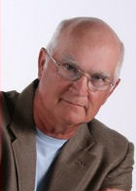

Thursday, November 9, 2017

Isle of Capri Casino

6:00 PM Pre-Dinner Social/Silent Auction

7:00 PM Program

____ ***YES*** I will be attending. _____ ***NO*** I am unable to attend.

Please reserve the following for me.

_____Title Sponsor $10,000

_____Presenting/Speaker Sponsor $5,000

_____Platinum/Silent Auction Sponsor $3,000

_____VIP Reception Sponsor $1,000

_____ GOLD Sponsor $ 500

Table of 8 – Reserved seating

_____ Reserve Table $ 400

Table of 8

_____ General Admission $ 60

_____Please bill my business. _____Check is enclosed.

Name of Business: _______________________________________

Signature: ______________________________________________